**Student Name: Weight: 2.3%**

**Student ID:** **Marks:** **/15**

# Lab: Group Functions and OLAP

## Equipment and Materials

For this lab, you will need:

* A Windows computer with a minimum of 16GB RAM and 250GB free disk space, capable of nested virtualization
* Access to ORACLE SQL*PLUS.
* Really Cheap Vacations Database created as part of previous learning activities.
* Physical Model for Really Cheap Vacations as created during previous learning activities.

## Instructions

1. Work through steps 2-7 INIDIVIDUALLY first, then arrange a time to come together with your small group. As a group, create one solution based on the best individual script for each problem. Further refine the solution as a group as needed.
2. Use the existing Really Cheap Vacations database and physical model to complete this lab.
3. Review the Really Cheap Vacations Physical Model.
4. Review the Really Cheap Vacation Database.
5. Using ***Labskeleton.sql*** as a starting point, write a single script that satisfies all the requirements outlined in the Problem Set.
6. Review the Tips for Succus section and the Marking Criteria section. Adjust your script as needed.
7. See Brightspace for exact due dates.
8. Only one submission per group is required. The submission should include:
   1. A single script file
   2. A spool file showing all results
   3. An attribution list that outlines the activities associated with completing this assignment

A sample attribution list is provided:

|  |  |  |  |
| --- | --- | --- | --- |
| Activity | Date | Resources | Tim spent (hours) |
| Initial group meeting | May 10, 2 PM | Dave, Fred, Kricket, Sara | 0.25 |
| Working through lab individually | May 11, 3 PM | Dave | 1 |
| Working through lab individually | May 11, 6 pm | Fred | 1 |
| Working through lab individually | May 12, 3 pm | Sara | 0.5 |
| Working through lab individually | May 12, 2 pm | Kricket | 0.5 |
| Final meeting to review individual submissions and create group submission | May 14, 3 PM | Dave, Fred, Kricket, Sara | 1.0 |
| Total Person Hours |  |  | 4.25 hours |

## Problem Set

1. For each vacation tour show the number of destinations and the total price for all the destinations. Only include vacation tours that have more than 3 destinations.

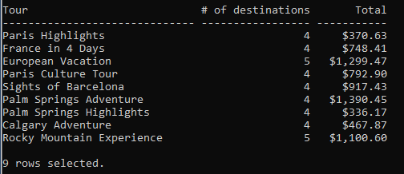

2. What is the total value of all the vacation tours taken by all customers?

  
Hint: A useful intermediate step would be to find the total value of vacation tours FOR each customer. This would yield the following:  
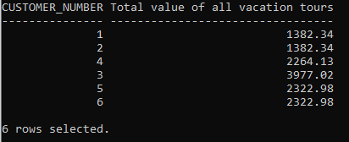

Please do NOT include code for this intermediate step in your solution.

## Tips for Success

1. Use column aliases to create a appropriate column headers.
2. Use ‘set linesize xxx’ which xxx is a number to set the width for output.
3. Use the column command to set the size of the columns, e.g.:  
   **column “aliasname” format A40**

**column stagename format A30**  
“A” means alphanumeric field with a length of 40 characters. For number columns use

**column “alaisname” format 9999.99**   
to show 4 digits before the decimal point and 2 digits after the decimal point.

1. Use:  
   **clear columns;**  
   at the end of each query to reset the column size.
2. Format of Break:  
   break on *columnname/alias* [on *columname/alias*]

## Marking Criteria

|  |  |  |  |  |  |  |  |
| --- | --- | --- | --- | --- | --- | --- | --- |
| **Categories** | | **Missing 0** | | **Needs Improvement 1** | **Good 2** | **Excellent 3** | **Score** |
| Correct Results (e.g # of rows, and values) | | 2+ questions incorrect | | NA | 1 question incorrect | Yes | **/3** |
| Output is formatted to match what is provided | | No attempt to format output | | 3+ formatting issues, lines wrap in output | 1-2 Formatting issues | Yes | **/3** |
| Solution will work on all datasets (e.g. no hard-coded values) | | 2 questions will not work for all datasets | |  | 1 question will not work for all datasets | Yes | **/3** |
| Attribution List Provided | | No | |  |  | Yes | **/3** |
| Spool File provided with commands included | | No | |  |  | Yes | **/3** |
|  |  | | **/15** | | | | |